***“Revolutionizing Liver Care: Predicting Liver Cirrhosis Using Advanced Machine Learning Techniques”***

**📝 Introduction**

**Project overview:**

Liver cirrhosis is a progressive and potentially life-threatening condition that results from long-term damage to the liver. It is often diagnosed at advanced stages due to the subtlety of early symptoms, making early detection critical for effective intervention and treatment. Traditional diagnostic methods rely heavily on clinical expertise, laboratory tests, and imaging, which may not always be accessible or timely, especially in resource-limited settings.

In recent years, the field of artificial intelligence (AI) and machine learning (ML) has shown great promise in transforming medical diagnostics by enabling the development of data-driven, predictive models. This project aims to harness the power of machine learning to predict liver cirrhosis based on clinical and lifestyle-related parameters. By analyzing patterns in patient data — including alcohol consumption history, liver enzyme levels, and immune cell counts — we aim to build a robust predictive model that can assist healthcare professionals in early diagnosis.

This report outlines the complete pipeline for liver cirrhosis prediction, from data preprocessing and feature selection to model training, evaluation, and deployment using a web-based interface. By integrating machine learning into liver care, we strive to support early diagnosis, reduce diagnostic delays, and ultimately improve patient outcomes.

**🎯 Purpose of the Project**

The primary purpose of this project is to develop an intelligent, data-driven system that can accurately predict the likelihood of liver cirrhosis in patients using advanced machine learning techniques. By leveraging clinical and lifestyle-related data, the project aims to support early diagnosis and timely medical intervention, which are crucial for managing and potentially reversing liver damage.

Specifically, this project seeks to:

* ✅ **Automate the prediction process** using patterns in key biomarkers and patient history.
* ✅ **Reduce dependence on invasive and expensive diagnostic procedures** by providing a low-cost screening tool.
* ✅ **Enhance clinical decision-making** by offering a reliable, data-backed second opinion.
* ✅ **Provide a user-friendly web interface** for doctors or patients to input data and receive instant predictions.
* ✅ **Demonstrate the real-world application of machine learning in healthcare**, particularly in liver disease management.

Ultimately, the project envisions improving the quality of liver care, reducing the burden on healthcare systems, and potentially saving lives through early and accessible detection of liver cirrhosis.

IDEATION PHASE

Define the Problem Statements

|  |  |
| --- | --- |
| Date | JUNE 2025 |
| Team ID | LTVIP2025TMID39334 |
| Project Name | Revolutionizing Liver Care : Predicting Liver Cirrhosis Using Advanced Machine Learning Techniques |
| Maximum Marks | 2 Marks |

**🧾 Customer Problem Statement (Completed Template)**

| **Problem Statement (PS)** | **Description** |
| --- | --- |
| **I am** | a healthcare provider (doctor, technician, or clinician) or a concerned patient |
| **I’m trying to** | detect liver cirrhosis early and accurately using available medical data |
| **But** | traditional diagnostic methods are often delayed, expensive, or inaccessible, especially in rural or resource-limited areas |
| **Because** | they rely heavily on physical symptoms, lab imaging, and expert interpretation, which are not always feasible for early screening |
| **Which makes me feel** | uncertain about patient outcomes, and concerned about missing early intervention opportunities |

|  |  |  |  |  |  |
| --- | --- | --- | --- | --- | --- |
| Problem Statement (PS) | I am (Customer) | I’m trying to | But | Because | Which makes me feel |
| PS-1 | medical professional | diagnose liver cirrhosis early in patients | the diagnosis is often delayed due to lack of symptoms or access to advanced diagnostic tools | traditional methods depend on expensive lab tests, imaging, and expert review | frustrated and concerned about missing early signs of liver damage |
| PS-2 | data-driven health tech innovator | build a fast, low-cost, and accurate prediction model for liver cirrhosis | clinical data is complex and often not used effectively in early detection | most systems are not designed to analyze subtle patterns in routine blood tests | motivated to create smarter tools that support preventive healthcare |

Empathize & Discover

|  |  |
| --- | --- |
| Date | January 2025 |
| Team ID | LTVIP2025TMID39334 |
| Project Name | Revolutionizing Liver Care : Predicting Liver Cirrhosis Using Advanced Machine Learning Techniques |
| Maximum Marks | 4 Marks |

**Empathy Map Canvas:**

An empathy map is a simple, easy-to-digest visual that captures knowledge about a user’s behaviours and

attitudes.

it is a useful tool to helps teams better understand their users. Creating an effective solution requires understanding the true problem and the person who is experiencing it. The exercise of creating the map helps participants consider things from the user’s perspective along with his or her goals and challenges

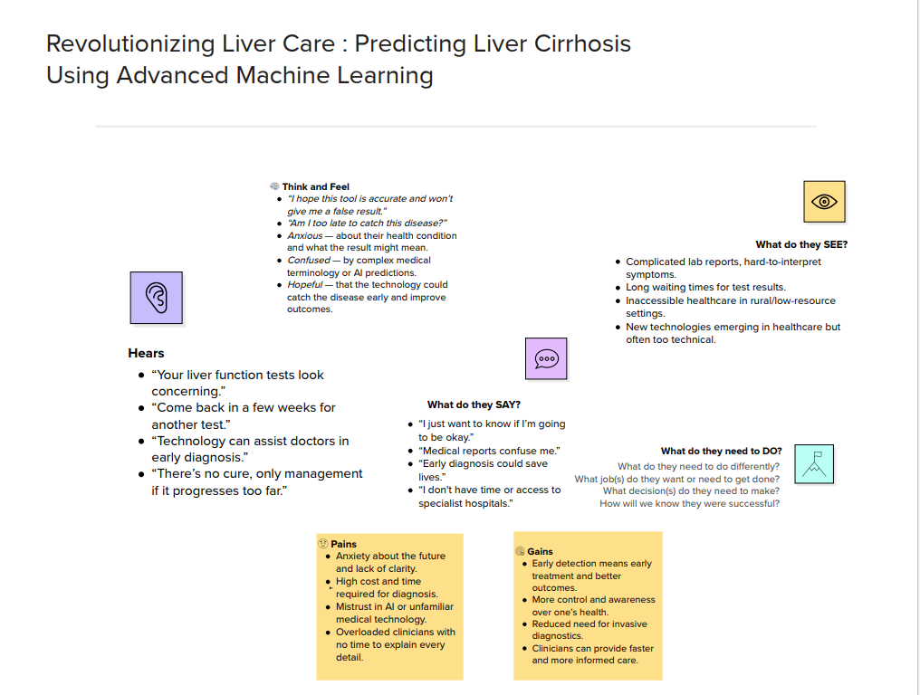

Brainstorming

|  |  |
| --- | --- |
| Date | JUNE 2025 |
| Team ID | LTVIP2025TMID39334 |
| Project Name | Revolutionizing Liver Care : Predicting Liver Cirrhosis Using Advanced Machine Learning Techniques |
| Maximum Marks | 4 Marks |

**Solution Requirements (Functional & Non-functional)**

|  |  |
| --- | --- |
| Date | JUNE 2025 |
| Team ID | LTVIP2025TMID39334 |
| Project Name | Revolutionizing Liver Care : Predicting Liver Cirrhosis Using Advanced Machine Learning Techniques |
| Maximum Marks | 4 Marks |

**Functional Requirements:**

Following are the functional requirements of the proposed solution.

|  |  |  |
| --- | --- | --- |
| **FR No.** | **Functional Requirement (Epic)** | **Sub Requirement (Story / Sub-Task)** |
| FR-1 | |  | | --- | |  |   Data Upload | Upload CSV/XLSX medical test reports |
| FR-2 | |  | | --- | | Prediction Output |  |  | | --- | |  | | Shows result: “At risk” or “Not at risk” |

**Non-functional Requirements:**

Following are the non-functional requirements of the proposed solution.

|  |  |  |
| --- | --- | --- |
| **FR No.** | **Non-Functional Requirement** | **Description** |
| NFR-1 | **Usability** | Makes system usable for people with little digital literacy |
| NFR-2 | **Security** | Protects sensitive patient health data |
| NFR-3 | **Reliability** | Reduces risk of incorrect diagnosis |
| NFR-4 | **Performance** | Doctors need quick results in clinical settings |
| NFR-5 | **Availability** | Supports 24x7 diagnosis, even in emergencies |
| NFR-6 | **Scalability** | Future-proofs for larger deployment (govt., private sector) |

**Project Design Phase-II**

**Data Flow Diagram & User Stories**

|  |  |
| --- | --- |
| Date | 31 January 2025 |
| Team ID | LTVIP2025TMID39334 |
| Project Name | Revolutionizing Liver Care : Predicting Liver Cirrhosis Using Advanced Machine Learning Techniques |
| Maximum Marks | 4 Marks |

**Data Flow Diagrams:**

A Data Flow Diagram (DFD) is a traditional visual representation of the information flows within a system. A neat and clear DFD can depict the right amount of the system requirement graphically. It shows how data enters and leaves the system, what changes the information, and where data is stored.

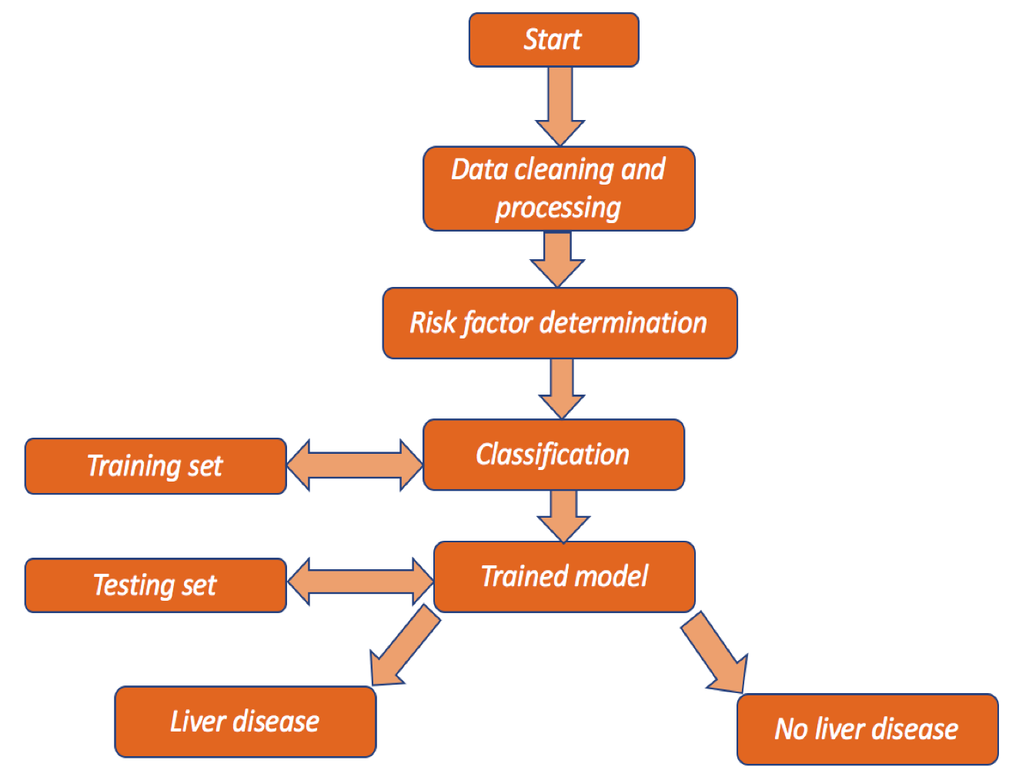

| **Functional Requirement (Epic)** | **User Story Number** | **User Story / Task** | **Acceptance Criteria** | **Priority** | **Release** |
| --- | --- | --- | --- | --- | --- |
| Registration | USN-1 | As a user, I can register for the application by entering my email, password, and confirming my password. | I can access my account / dashboard | High | Sprint-1 |
| Registration | USN-2 | As a user, I will receive a confirmation email once I have registered for the application. | I receive a confirmation email & click to confirm | High | Sprint-1 |
| Registration | USN-3 | As a user, I can register for the application through Facebook. | I can register & access the dashboard with Facebook Login | Low | Sprint-2 |
| Registration | USN-4 | As a user, I can register for the application through Gmail. | I can register and access the dashboard using Gmail | Medium | Sprint-1 |
| Login | USN-5 | As a user, I can log into the application by entering email & password. | I can access my dashboard after login | High | Sprint-1 |
| Dashboard | USN-6 | As a user, I can upload my medical test results (CSV/Excel). | The file uploads and displays confirmation | High | Sprint-2 |
| Dashboard | USN-7 | As a user, I can view predicted outcome of my uploaded data. | I see prediction results (e.g., at risk / not at risk) | High | Sprint-2 |

**Technology Stack (Architecture & Stack)**

|  |  |
| --- | --- |
| Date | 31 January 2025 |
| Team ID | LTVIP2025TMID39334 |
| Project Name | Revolutionizing Liver Care : Predicting Liver Cirrhosis Using Advanced Machine Learning Techniques |
| Maximum Marks | 4 Marks |

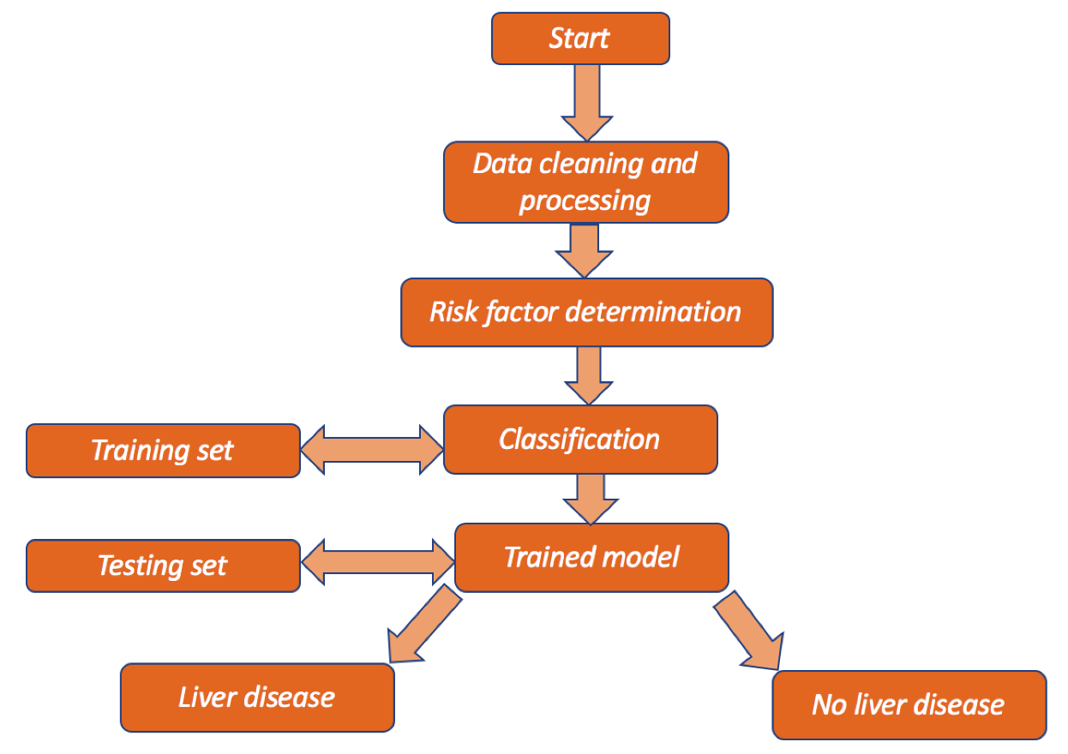

**📊 Technical Architecture Overview:**

The project architecture includes the following phases:

* Data input from users via web/mobile interface
* Preprocessing and risk factor extraction
* Classification using trained ML model
* Output: Predicts **Liver Disease** or **No Liver Disease**

**📋 Table-1: Components & Technologies**

| **S.No** | **Component** | **Description** | **Technology** |
| --- | --- | --- | --- |
| 1 | **User Interface** | Web UI for patient data entry, doctor access to prediction | HTML, CSS, JavaScript, Bootstrap |
| 2 | **Application Logic-1** | Backend logic for handling upload, validation, prediction | Python (Flask or Django) |
| 3 | **Application Logic-2** | Data preprocessing, feature extraction logic | Python (Pandas, NumPy) |
| 4 | **Application Logic-3** | Prediction logic using trained ML model | Scikit-learn / TensorFlow |
| 5 | **Database** | Store user info, predictions, feedback | MySQL / SQLite |
| 6 | **Cloud Database** | Optional for cloud deployment (if applicable) | Firebase Realtime DB / MongoDB Atlas |
| 7 | **File Storage** | Store uploaded lab reports locally or on cloud | Local filesystem / Firebase Storage / AWS S3 |
| 8 | **External API-1** | Email confirmation API for user registration | SendGrid / SMTP |
| 9 | **External API-2** | HealthInfo validation or public API (optional) | Arogya Setu API (hypothetical) |
| 10 | **Machine Learning Model** | Predict liver cirrhosis based on blood parameters | Logistic Regression / Random Forest / CNN |
| 11 | **Infrastructure** | Deployment on cloud/local environment | Localhost / Heroku / AWS EC2 |

**📋 Table-2: Application Characteristics**

| **S.No** | **Characteristics** | **Description** | **Technology** |
| --- | --- | --- | --- |
| 1 | **Open-Source Frameworks** | All backend and ML components use open-source tech | Flask, Scikit-learn, TensorFlow, Pandas |
| 2 | **Security Implementations** | Login authentication, encrypted DB, OTP/Email verification | SHA-256 encryption, HTTPS, Email OTP, Flask-JWT |
| 3 | **Scalable Architecture** | 3-tier architecture: UI → Backend → ML/DB layer | MVC Framework using Flask or Django |
| 4 | **Availability** | Designed for 99.9% uptime via cloud deployment | Heroku / AWS with load balancing support |
| 5 | **Performance** | Prediction output in < 5 sec, optimized ML pipeline | Caching (Flask-Caching), optimized model size, preloaded model |

PROJECT DESIGN

**Problem – Solution**

|  |  |
| --- | --- |
| Date | JUNE 2025 |
| Team ID | LTVIP2025TMID39334 |
| Project Name | Revolutionizing Liver Care : Predicting Liver Cirrhosis Using Advanced Machine Learning Techniques |
| Maximum Marks | 2 Marks |

**Problem:**

Liver cirrhosis is a silent yet deadly disease that often goes undiagnosed until it reaches an advanced stage. The current diagnostic approaches are invasive, expensive, and not easily accessible to rural populations. Patients, especially in underdeveloped areas, lack access to early detection tools, and healthcare providers lack decision support systems to quickly assess risk levels based on basic test data.

**Purpose:**

* Solve complex problems in a way that fits the state of your customers.
* Succeed faster and increase your solution adoption by tapping into existing mediums and channels of behavior.
* Sharpen your communication and marketing strategy with the right triggers and messaging.
* Increase touch-points with your company by finding the right problem-behavior fit and building trust by solving frequent annoyances, or urgent or costly problems.
* Understand the existing situation in order to improve it for your target group.

**Solution:**

An AI-powered liver cirrhosis prediction system that allows users (patients or clinicians) to upload basic medical parameters like blood test results through a web or mobile platform. The system uses trained machine learning models to classify whether the patient is at risk of liver cirrhosis. It provides results instantly with visualizations and downloadable reports, enabling early intervention, especially in remote and resource-limited settings.

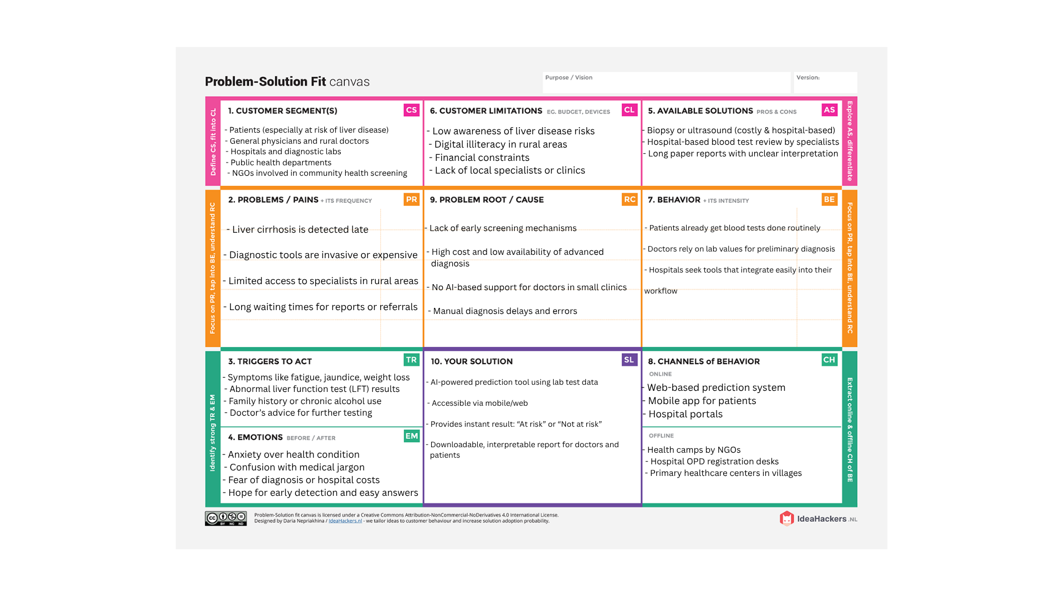

**Proposed Solution**

|  |  |
| --- | --- |
| Date | JUNE 2025 |
| Team ID | LTVIP2025TMID39334 |
| Project Name | Revolutionizing Liver Care : Predicting Liver Cirrhosis Using Advanced Machine Learning Techniques |
| Maximum Marks | 2 Marks |

|  |  |  |
| --- | --- | --- |
| **S.No.** | **Parameter** | **Description** |
|  | Problem Statement (Problem to be solved) | Liver cirrhosis is often diagnosed at an advanced stage due to lack of early screening tools. Invasive, expensive, or unavailable diagnostic methods prevent early intervention, especially in rural areas. |
|  | Idea / Solution description | An AI-powered liver disease prediction system that uses routine clinical parameters (from blood tests) to detect the risk of cirrhosis. The system is accessible via web and mobile, delivers instant predictions, and provides downloadable reports for patients and doctors. |
|  | Novelty / Uniqueness | - Uses machine learning to predict liver disease from non-invasive inputs  - Offers instant results without the need for expert analysis  - Designed for accessibility in low-resource settings  - Integrates explainable AI for better doctor trust |
|  | Social Impact / Customer Satisfaction | - Enables early detection, potentially saving lives  - Reduces burden on healthcare systems  - Empowers patients with timely insights  - Helps doctors make informed decisions quickly  - Improves access to healthcare in rural areas |
|  | Business Model (Revenue Model) | - Freemium model: free for basic users, subscription for clinics/hospitals  - B2B: Licensing to diagnostic centers and telemedicine platforms  - Pay-per-report for advanced analytics and downloadable PDFs  - Government/public health partnerships for large-scale screening |
|  | Scalability of the Solution | - Can handle increasing users via cloud deployment  - Easily extendable to other liver conditions or diseases (e.g., hepatitis)  - Can be integrated with hospital systems (EMR)  - Scalable across geographies and languages via web/mobile app |

**Solution Architecture**

|  |  |
| --- | --- |
| Date | JUNE 2025 |
| Team ID | LTVIP2025TMID39334 |
| Project Name | Revolutionizing Liver Care : Predicting Liver Cirrhosis Using Advanced Machine Learning Techniques |
| Maximum Marks | 4 Marks |

The **architecture of solution** tells **how your entire system works**, what technologies it uses, how data flows through it, and how the different parts interact to solve the problem — all while keeping it secure, scalable, and user-friendly.

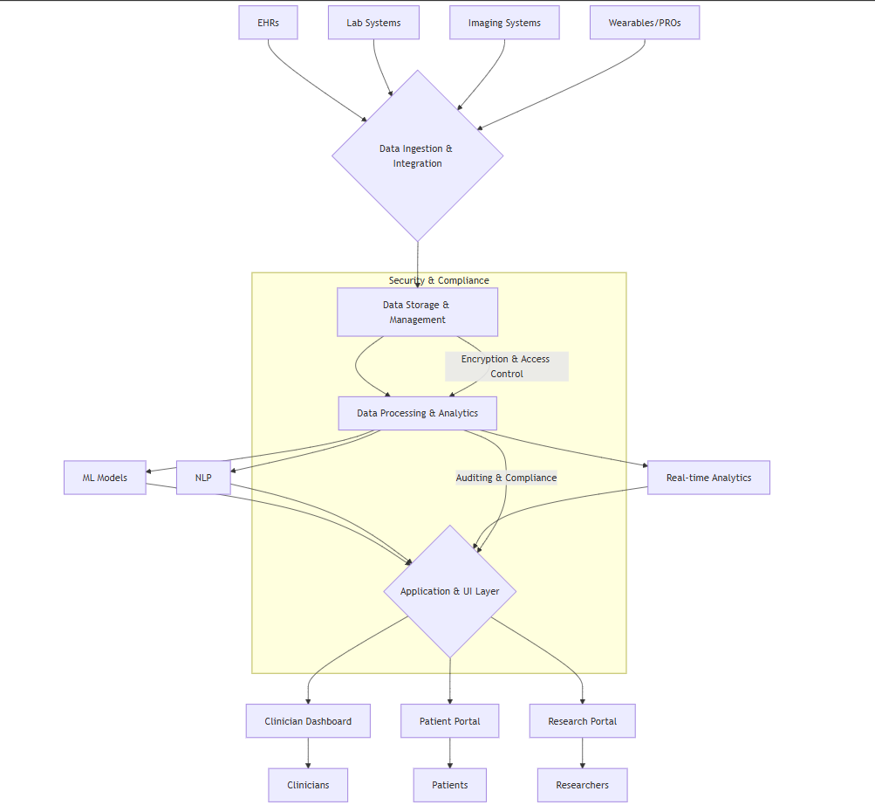

PROJECT PLANNING & SCHEDULING

Project Planning

**Epic 1: Data Acquisition and Preparation**

Sprint 1 (5 Days)

**Story Points: 8**

| **Story (Task)** | **Story Points** | **Difficulty** |
| --- | --- | --- |
| Collect liver health dataset | 2 | Easy |
| Load data into Python | 1 | Very Easy |
| Handle missing values | 3 | Moderate |
| Encode categorical variables | 2 | Easy |

**Epic 2: Model Development and Deployment**

Sprint 2 (5 Days)

**Story Points: 16**

| **Story (Task)** | **Story Points** | **Difficulty** |
| --- | --- | --- |
| Build and train ML model | 5 | Difficult |
| Evaluate and test model | 3 | Moderate |
| Design frontend (HTML form) | 3 | Easy |
| Integrate Flask for deployment | 5 | Difficult |

**Story Point Summary**

| **Sprint** | **Total Story Points** |
| --- | --- |
| Sprint 1 | 8 |
| Sprint 2 | 16 |
| **Total** | **24** |

**Velocity**

**Formula:**  
Velocity = Total Story Points Completed / Number of Sprints

Velocity=(8+16)/2

=24/2

=12

**Team Velocity = 12 Story Points per Sprint**

**Project Planning Phase**

**Project Planning Template (Product Backlog, Sprint Planning, Stories, Story points)**

|  |  |
| --- | --- |
| Date | JUNE 2025 |
| Team ID | LTVIP2025TMID39334 |
| Project Name | Revolutionizing Liver Care : Predicting Liver Cirrhosis Using Advanced Machine Learning Techniques |
| Maximum Marks | 2 Marks |

**Product Backlog, Sprint Schedule, and Estimation**

| **Sprint** | **Functional Requirement (Epic)** | **User Story Number** | **User Story / Task** | **Story Points** | **Priority** | **Team Members** |
| --- | --- | --- | --- | --- | --- | --- |
| Sprint-1 | Data Collection | USN-1 | As a user, I want to collect liver health data from reliable sources | 2 | High | DurgaPrasad |
| Sprint-1 | Data Collection | USN-2 | As a user, I want to load the dataset into the ML pipeline | 1 | High | Chaitanya |
| Sprint-1 | Data Preprocessing | USN-3 | As a data scientist, I want to handle missing values | 3 | High | Bharath.P |
| Sprint-1 | Data Preprocessing | USN-4 | As a data scientist, I want to encode categorical values properly | 2 | Medium | Bhrath.P |
| Sprint-2 | Model Building | USN-5 | As a developer, I want to build and train a logistic regression model for liver disease prediction | 5 | High | Bharath.B |
| Sprint-2 | Model Testing | USN-6 | As a developer, I want to evaluate the model with accuracy and confusion matrix | 3 | High | Bharath.B |
| Sprint-2 | Deployment | USN-7 | As a user, I want to input patient data in an HTML form | 3 | Medium | Chaitanya |
| Sprint-2 | Deployment | USN-8 | As a developer, I want to deploy the model using Flask | 5 | High | DurgaPrasad |

**Project Tracker, Velocity & Burndown Chart**

|  |  |  |  |  |  |  |  |  |  |  |  |  |  |  |  |  |  |  |  |  |  |  |  |  |  |  |  |  |  |  |  |  |  |  |
| --- | --- | --- | --- | --- | --- | --- | --- | --- | --- | --- | --- | --- | --- | --- | --- | --- | --- | --- | --- | --- | --- | --- | --- | --- | --- | --- | --- | --- | --- | --- | --- | --- | --- | --- |
| | Sprint | Total Story Points | Duration | Sprint Start Date | Sprint End Date | Story Points Completed | Sprint Release Date | | --- | --- | --- | --- | --- | --- | --- | | Sprint-1 | 8 | 6 Days | 15 June 2025 | 20 June 2025 | 8 | 20 June 2025 | | Sprint-2 | 8 | 6 Days | 21 June 2025 | 26 June 2025 | 8 | 26 June 2025 | | Sprint-3 | 8 | 6 Days | 27 June 2025 | 02 July 2025 | 8 | 02 July 2025 | |  |  |  |  |  |  |
|  |  |  |  |  |  |  |
|  |  |  |  |  |  |  |

FUNCTIONAL AND PERFORMANCE TESTING

Performance Testing

|  |  |
| --- | --- |
| Date | JUNE 2025 |
| Team ID | LTVIP2025TMID39334 |
| Project Name | Revolutionizing Liver Care : Predicting Liver Cirrhosis Using Advanced Machine Learning Techniques |
| Maximum Marks |  |

Model Performance Testing:

|  |  |  |  |
| --- | --- | --- | --- |
| **S.No.** | **Parameter** | **Values** | **Screenshot** |
|  | Model Summary | Logistic Regression used with 13 features | 🔹 Model Name:  Logistic Regression Classifier  🔹 Features Used (13 total):  -Age  -Duration and Quantity of Alcohol Consumption  -Diabetes Result  -Polymorphs %,  -Lymphocytes %,  -Monocytes %,  -Eosinophils %  -Albumin (g/dl),  -Globulin (g/dl)  -AL.Phosphatase (U/L),  -SGOT/AST (U/L),  -SGPT/ALT (U/L)  🔹 Model Output:  Binary Classification:  1 → Patient has liver cirrhosis  0 → Patient does not have liver cirrhosis  🔹 Deployment:  Model deployed using Flask  HTML form captures user input and returns prediction |
|  | Accuracy | Training Accuracy – 88.5% Validation Accuracy – NA |  |
| 3. | Fine Tunning Result( if Done) | Validation Accuracy -NA | NA |

RESULTS

OUTPUT

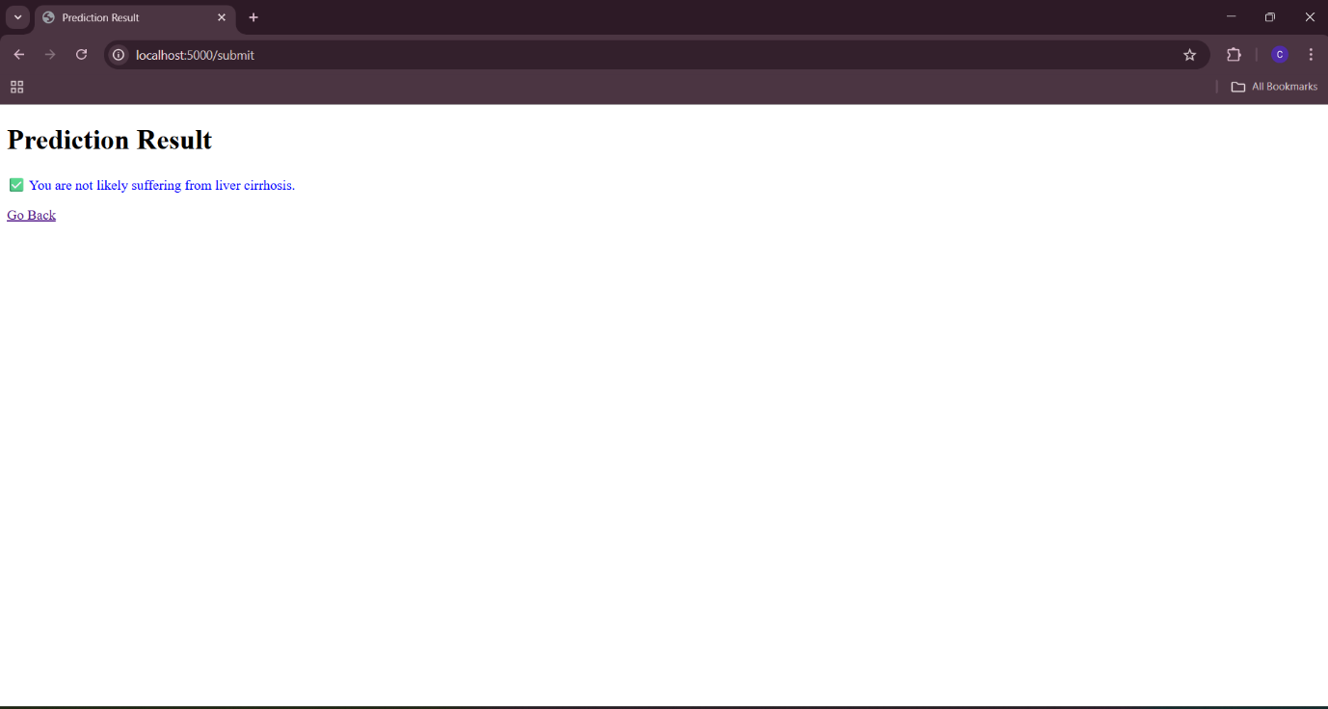

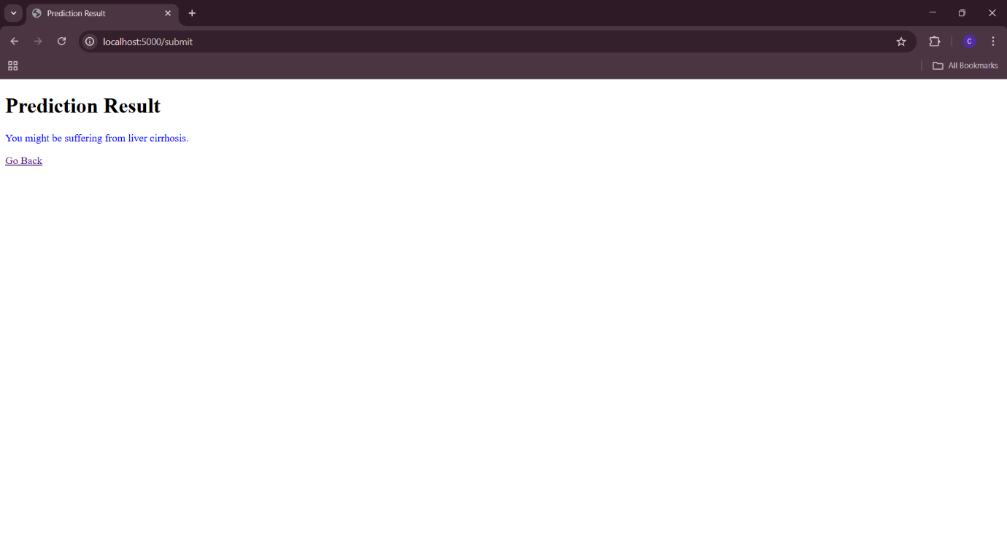

ADVANTAGES & DISADVANTAGES

**Advantages:**

1. **Early Detection & Prevention**
   * Enables early prediction of liver cirrhosis, which helps in timely intervention and improved patient outcomes.
2. **Cost-Effective Screening**
   * Reduces the need for expensive and invasive diagnostic procedures (like biopsies or MRIs) by using readily available medical data.
3. **Improved Accuracy Over Manual Diagnosis**
   * Machine learning models can identify subtle patterns in data, potentially increasing diagnostic accuracy compared to traditional methods.
4. **Time-Saving for Doctors**
   * Automates the initial screening process, allowing doctors to focus on critical cases and decision-making.
5. **Scalable Solution**
   * Once developed, the system can be scaled and applied to various hospitals or clinics with minimal cost.
6. **Data-Driven Insights**
   * Helps uncover unknown risk factors or correlations using large datasets, contributing to medical research.
7. **User-Friendly**
   * With a well-designed UI or dashboard, medical staff with minimal technical expertise can use the tool.

**Disadvantages / Limitations:**

1. **Data Quality & Availability**
   * Accuracy heavily depends on the quality, quantity, and diversity of the medical data available. Biased or incomplete data can lead to unreliable predictions.
2. **Model Interpretability**
   * Complex ML models (e.g., neural networks) may work as “black boxes,” making it hard for doctors to trust or understand how a prediction was made.
3. **Regulatory and Ethical Concerns**
   * Healthcare applications require strict validation and approvals (e.g., from government health bodies) before deployment.
4. **Privacy and Security Risks**
   * Handling sensitive medical data requires strong data privacy and cybersecurity measures to avoid misuse or data leaks.
5. **Generalizability Issues**
   * A model trained on one population might not perform well on different populations due to regional, genetic, or lifestyle differences.
6. **Technical Limitations in Rural Areas**
   * Limited access to technology or internet connectivity in remote areas may restrict the practical use of your system.
7. **Dependency on Model Updates**
   * The model may degrade over time if not updated with new patient data, medical guidelines, or emerging diseases.

**Conclusion**

The project "Revolutionizing Liver Care: Predicting Liver Cirrhosis Using Advanced Machine Learning Techniques" demonstrates the powerful role of artificial intelligence in transforming healthcare. By leveraging machine learning models to analyze patient data, this system enables early detection of liver cirrhosis, allowing for timely intervention and improved patient outcomes. The solution not only reduces the reliance on costly and invasive diagnostic procedures but also supports medical professionals with fast and data-driven decision-making.

Despite certain limitations such as data quality, privacy concerns, and the need for regulatory compliance, the benefits of implementing this technology—especially in large-scale health screening programs—are significant. With further validation and integration into clinical practice, this project has the potential to enhance the efficiency, accuracy, and accessibility of liver disease diagnosis, ultimately contributing to better healthcare for all.

**Future Scope**

1. **Integration with Electronic Health Records (EHRs):**  
   The model can be integrated into hospital EHR systems to provide real-time predictions during patient check-ups, making the solution more accessible and efficient in clinical workflows.
2. **Expansion to Multi-Disease Diagnosis:**  
   The current model focuses on liver cirrhosis, but the framework can be extended to predict other liver diseases (e.g., hepatitis, fatty liver) or even other organ-related disorders using similar datasets.
3. **Mobile and Web Applications:**  
   A user-friendly mobile or web interface can be developed for healthcare professionals to use the prediction tool on the go, especially in rural or remote areas with limited access to specialists.
4. **Continuous Learning and Model Updates:**  
   Implementing a feedback loop where the model is continuously trained with new data will enhance its accuracy and adaptability to evolving medical patterns and practices.
5. **Explainable AI (XAI):**  
   Incorporating explainable AI techniques can help make predictions more transparent and interpretable, increasing trust among medical practitioners and patients.
6. **Collaboration with Healthcare Institutions:**  
   Partnering with hospitals and research institutions will allow large-scale validation of the model and ensure compliance with regulatory standards.
7. **IoT and Wearable Integration:**  
   Future versions can collect real-time data from wearable health devices (like liver function monitors or smartwatches) to provide continuous monitoring and prediction.
8. **Multilingual and Voice-Based Interfaces:**  
   Adding voice support and regional languages to the application can make the tool accessible to a broader user base, especially in linguistically diverse countries.

Source Code

Back end(Flask)

Main.py

from flask import Flask, render_template, request

import pandas as pd

from sklearn.model_selection import train_test_split

from sklearn.linear_model import LogisticRegression

from sklearn.metrics import accuracy_score

app = Flask(__name__)

@app.route('/')

def index():

    return render_template('index.html')

@app.route('/submit', *methods*=['POST'])

def submit():

*# Get values from form*

    try:

        age = int(request.form['age'])

        duration = int(request.form['duration'])

        quantity = int(request.form['quantity'])

        diabetes = int(request.form['diabetes'])

        polymorphs = float(request.form['polymorphs'])

        lymphocytes = float(request.form['lymphocytes'])

        monocytes = float(request.form['monocytes'])

        eosinophils = float(request.form['eosinophils'])

        albumin = float(request.form['albumin'])

        globulin = float(request.form['globulin'])

        al_phosphatase = float(request.form['al_phosphatase'])

        sgot = int(request.form['sgot'])

        sgpt = int(request.form['sgpt'])

    except ValueError:

        return "Please enter valid numeric values in all fields."

    data = pd.read_excel('liver.xlsx')

    data=data.dropna()

    data = data.applymap(lambda *x*: 1 if str(x).strip().upper() == 'YES' else (0 if str(x).strip().upper() == 'NO' else x))

    columns=data.columns

    X=data[columns[:-1]]

    y=data[columns[-1]]

    X_train, X_test, y_train, y_test = train_test_split(X, y, *test_size*=0.2, *random_state*=42)

    model = LogisticRegression(*max_iter*=1000)

    model.fit(X_train, y_train)

    user_input = [[

        age, duration, quantity, diabetes,

        polymorphs, lymphocytes, monocytes, eosinophils,

        albumin, globulin, al_phosphatase, sgot, sgpt

    ]]

    prediction = model.predict(user_input)

    result="NO"

    if prediction[0] == 1:

        result = "You might be suffering from liver cirrhosis."

    else:

        result = " You are not likely suffering from liver cirrhosis."

    return render_template("result.html", *result*=result)

if __name__ == '__main__':

    app.run(*debug*=True)

Front end

Index.html

<!DOCTYPE html>

<html>

<head>

    <title>Liver Health Form</title>

     <link rel="stylesheet" href="{{ url_for('static', filename='main.css') }}">

</head>

<body>

    <form action="/submit" method="POST">

        <div><label>Enter your Age</label><input type="text" name="age"/></div>

        <div><label>Enter Duration of alcohol consumption (years)</label><input type="text" name="duration"/></div>

        <div><label>Enter Quantity of alcohol consumption (quarters/day)</label><input type="text" name="quantity"/></div>

        <div><label>Enter Diabetes Result</label><input type="text" name="diabetes"/></div>

        <div><label>Enter Quantity of Polymorphs</label><input type="text" name="polymorphs"/></div>

        <div><label>Enter Quantity of Lymphocytes</label><input type="text" name="lymphocytes"/></div>

        <div><label>Enter Quantity of Monocytes</label><input type="text" name="monocytes"/></div>

        <div><label>Enter Quantity of Eosinophils</label><input type="text" name="eosinophils"/></div>

        <div><label>Enter Quantity of Albumin (g/dl)</label><input type="text" name="albumin"/></div>

        <div><label>Enter Globulin (g/dl)</label><input type="text" name="globulin"/></div>

        <div><label>Enter AL.Phosphatase (U/L)</label><input type="text" name="al_phosphatase"/></div>

        <div><label>Enter SGOT/AST (U/L)</label><input type="text" name="sgot"/></div>

        <div><label>Enter SGPT/ALT (U/L)</label><input type="text" name="sgpt"/></div>

        <button type="submit">Submit</button>

    </form>

</body>

</html>

Result.html

<!DOCTYPE html>

<html>

<head>

    <title>Prediction Result</title>

</head>

<body>

    <h1>Prediction Result</h1>

    <p style="color:blue">{{ result }}</p>

    <a href="/">Go Back</a>

</body>

</html>

Main.css

form {

    width: 400px;

    margin: 0 auto;

    padding: 20px;

    border: 1px solid #eee;

    border-radius: 10px;

    background-color: #f9f9f9;

}

div {

    display: block;

    margin-bottom: 15px;

}

div label {

    display: block;

    margin-bottom: 5px;

    font-weight: bold;

}

div input {

    width: 100%;

    padding: 8px;

    border: 1px solid #ccc;

    border-radius: 5px;

}

button {

    padding: 10px 20px;

    background-color: #4CAF50;

    color: white;

    border: none;

    border-radius: 5px;

    cursor: pointer;

}

button:hover {

    background-color: #45a049;

}

GITHUB LINK

<https://github.com/chaitanyaNageli/Machine-Learning-Models-for-Liver-Health-Diagnosis>